## **Overview**

**Spearman’s correlation (2-tailed):** correlation among the presence of flaws, item difficulty, and average time time take on question

* Number of flaws and average time taken on question
* Total correct and average time taken on question

Analysis:

Total correct and average time taken on question

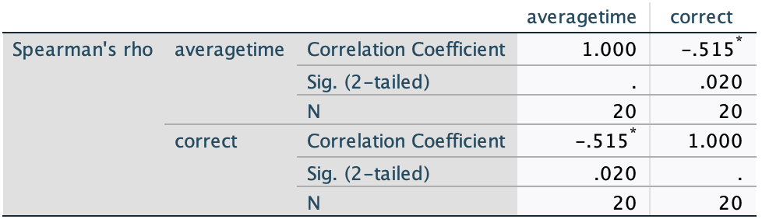

Variables:

* Correct - refers to the item difficulty for each question
* Averagetime = the average time students spent on each question

The correlation coefficient is -.515 which suggests there is a moderately negative correlation between the item difficulty and the average time students spend on a question. As the average time increases, item difficulty decreases. This suggests students that take longer on a question are more likely to get the question wrong.

The p-value is 0.020 which means this is statistically significant. There is a significant relationship between the two variables and it is unlikely due to chance. The analysis was based on a sample size of 20 observations, which may limit the statistical power of the test.

Number of flaws and average time taken

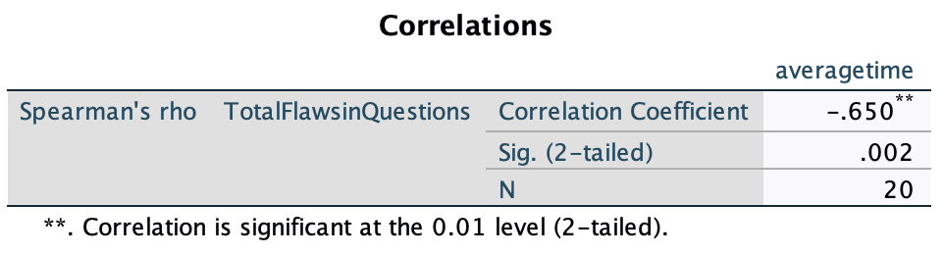

Variables:

* TotalFlawsinQuestions - refers to the number of flaws in each question
* Averagetime = the average time students spent on each question

The correlation coefficient is -.650 which suggests there is a negative correlation between the number of flaws and the average time students spend on a question. As the number of flaws increases, the average time decreases. This suggests that flaws may make it easier for students to answer the questions quicker, could be because they aren’t thinking too much about the content or because they know they don’t know the answer and just guess.

The p-value is 0.002 which means this is statistically significant. There is a significant relationship between the two variables and it is unlikely due to chance. The analysis was based on a sample size of 20 observations, which may limit the statistical power of the test.